Secrets of St-Rémy #4: Favorite Boutiques

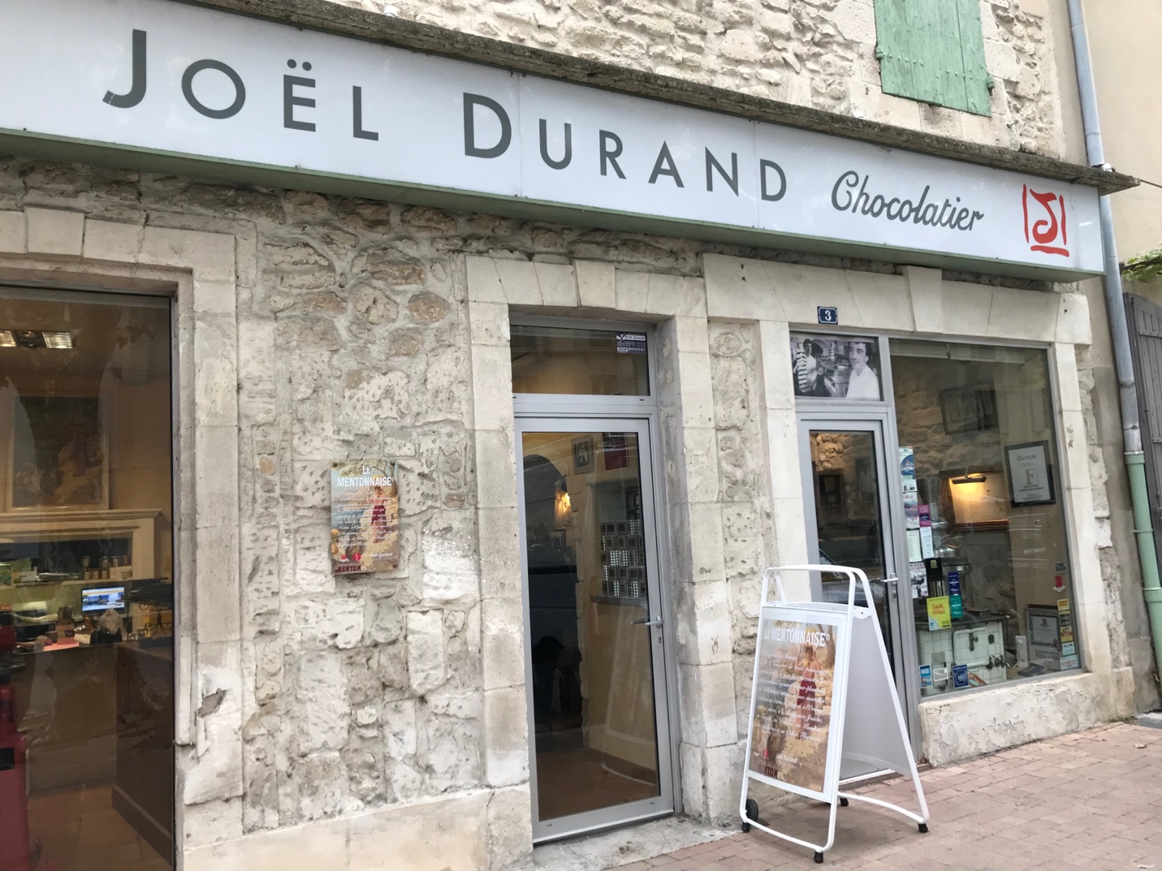

My wife Val and I live part of the year in St-Rémy-de-Provence, a charming town between Marseille and Avignon. I’ve written a guidebook about the area, An Insider’s Guide to Provence, where I share some of our favorite things to see and do. This series of articles is based on that book.

St-Rémy is full of all kinds of interesting shops and boutiques, specializing in everything from chocolate to cheese to stylish footwear. Here are a few of our favorites.

Chocolate!
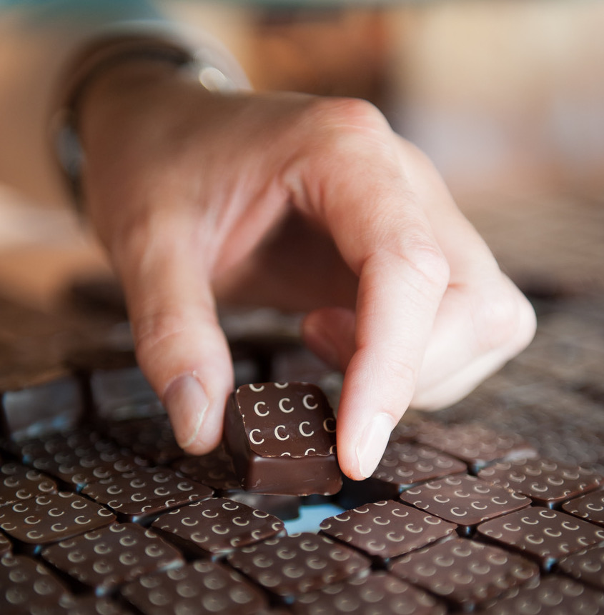
St-Rémy is lucky to have its own Master Chocolatier, Joël Durand, who is considered one of the top chocolate makers in France. People come from all over to visit his shop at 3 Boulevard Victor Hugo, and for good reason. Durand was a precocious talent, becoming the pastry chef at a Michelin-starred restaurant when he was only 17. He later decided to focus on chocolate and opened his boutique in St-Rémy. Be sure to sample his Alphabet of Flavors—chocolates stamped with different letters of the alphabet. Each has a unique flavor, like chocolate with rosemary or chocolate with lavender (my favorite is chocolate with lime—so good.) Buy some for your friends and spell out a message!
Shoes
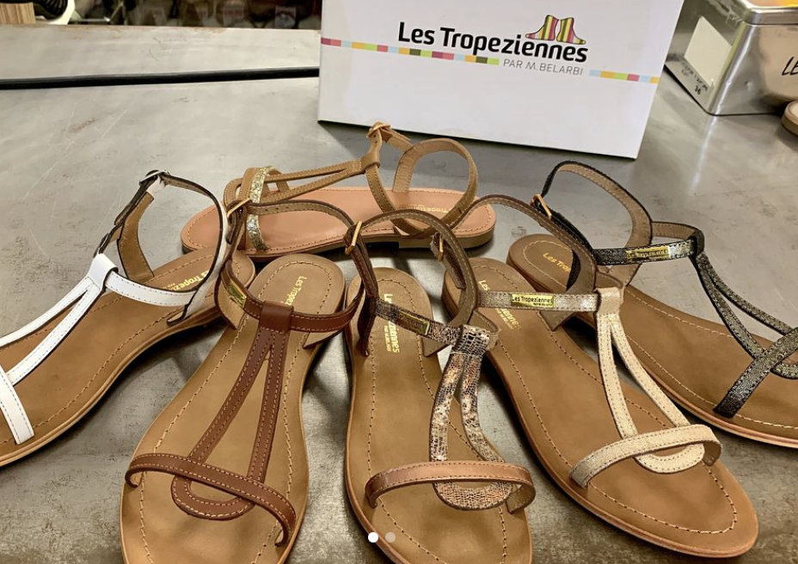
Want some new kicks for your Provence vacation? Val and her girlfriends love Tendances, the stylish shoe store in St-Rémy’s main square, at 1 Place Jules Pelissier. It offers a wide variety of shoes, at multiple price points, for women, men, and children.
Ice Cream
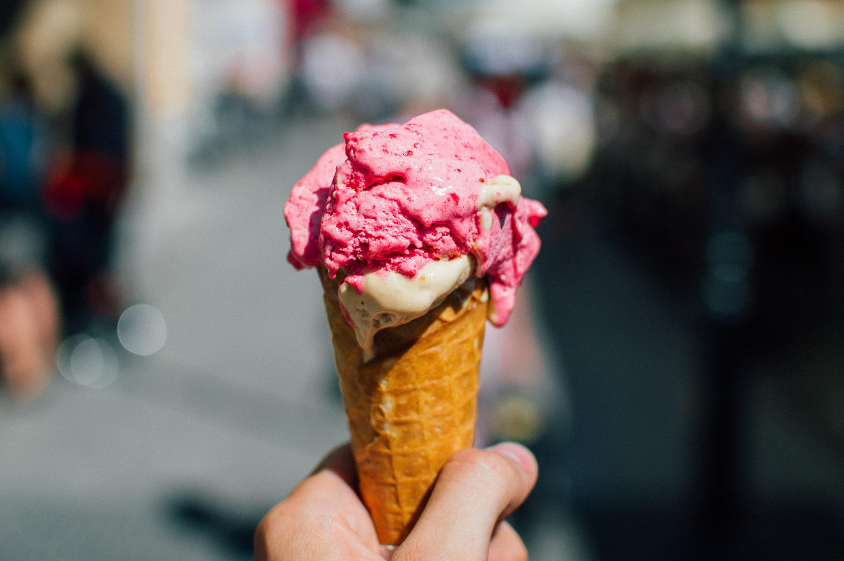
Provence can get hot in the summer and there’s nothing better for cooling off than a dish of ice cream. Happily for you, St-Rémy has two great places to get your fix. For delicious home-made ice cream and sorbet, I like Glacés de Saint Rémy at 28 Boulevard Victor Hugo. For fancy ice cream dishes, the place to go is Le Roma at 33 Boulevard Marceau.
Leather Goods

Pallas Cuir has been making fine leather goods for generations—jackets, gloves, handbags, and more. Their People’s Square shop at 11 Rue Lafayette offers not only their own products but also those from famous names like Lacoste, Calvin Klein, and Tommy Hilfiger. If you’d like to see even more, visit the large Pallas Cuir showroom a few miles west of town at the intersection of the D99 and D570N roads.

Cheese

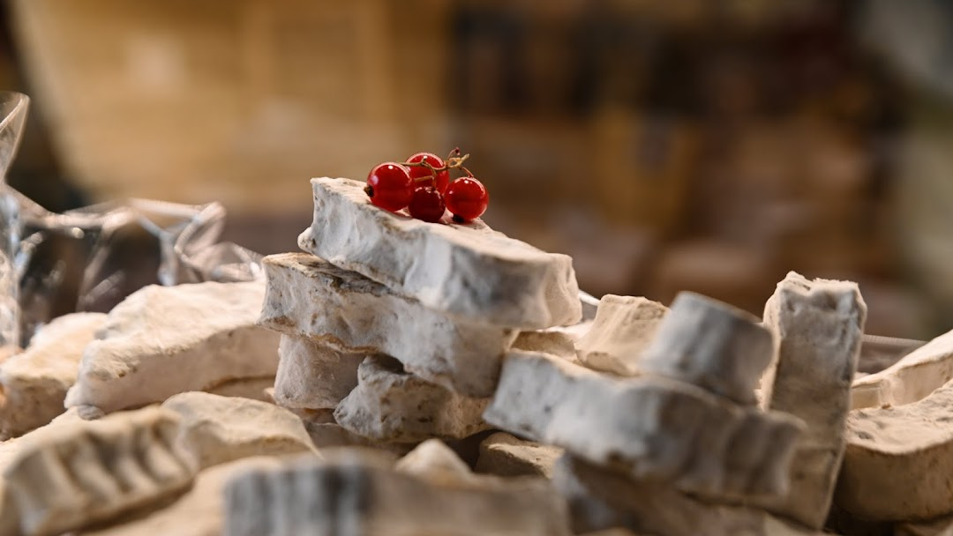

Charles de Gaulle once complained about the fractious French by asking, “How do you govern a country with 246 kinds of cheese?” While all that diversity may be tough for the French president, it’s heaven for cheese-lovers! Try a few of those many varieties at the best cheese shop in town, La Cave aux Fromages, at 1 Place Joseph Hilaire.

Olive Oil
https://www.youtube.com/watch?v=mG_YQDBT2s0
Olive oil has been produced in St-Rémy since ancient times—the first Christian king of France, Clovis, was baptized using St-Rémy olive oil in the year 496.

If you would like to taste some of the best olive oil around, go to the Moulin du Calenquet shop at 8 rue de la Commune. If you’ve never done an olive oil tasting, it’s interesting to find how different the various oils taste, and how some give you a little burn on the back of your throat. The Calenquet shop also sells olives (of course) and various olive-based products like tapenade.

You can also visit the olive oil mill itself, to do a tasting or to buy their products. It’s just a few miles west of town on the Vieux Chemin d’Arles (follow the signs.)

Hair Styling

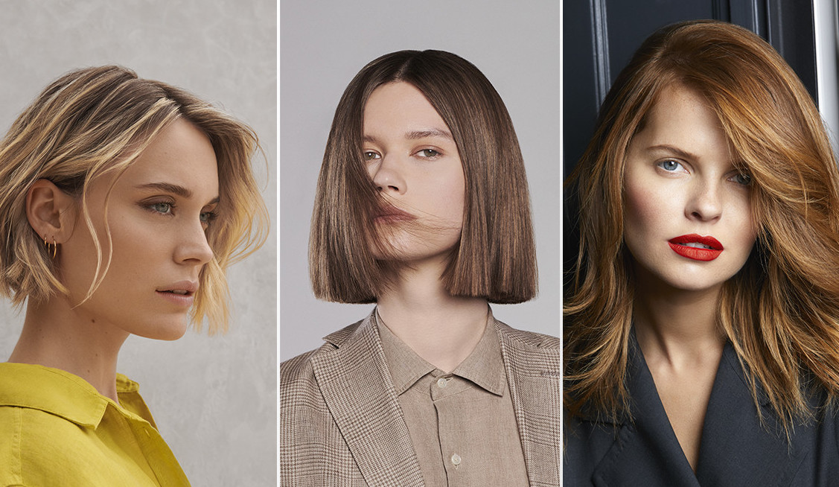

Everyone needs a stylist sometimes, even on vacation. My favorite place is Franck Provost at 13 Boulevard Victor Hugo; they’ve been cutting my hair for years. A wide range of services is provided, for both women and men, at reasonable prices. And the staff speaks English!

Image Credits
Joël Durand photos: from Joël Durand
Shoes: from Tendances Instagram
Ice cream: from Pixabay (royalty-free images)
Leather: from the Pallas Cuir website
Cheese: from the La Cave aux Fromages website
Olive oil: from the Calenquet website (I don’t know how to embed videos but hopefully you do!)
Styling: from the Franck Provost website

